Structural (code-based) Testing

- Also called white-box testing

- Derivation of test cases according to program structure. Knowledge of the program is used to identify additional test cases

- Objective is to exercise all program statements (not all path combinations)
Binary search (Ada)
procedure

Binary_search (Key: ELEM ; T: ELEM_ARRAY ;
Found:
in out
BOOLEAN ; L:
in out
ELEM_INDEX)
is
- Preconditions
-- T’FIRST < =T’LAST and
-- forall i: T’FIRST..T’LAST-1, T (i) <= T(i+1)

Bott : ELEM_INDEX := T’FIRST ;

Top : ELEM_INDEX := T’LAST ;

Mid : ELEM_INDEX;
begin

L := (T’FIRST + T’LAST ) / 2;

Found := T( L ) = Key;

while

Bott <= Top
and not

Found
loop

Mid := (Top + Bott) / 2;

if

T( Mid ) = Key
then

Found := true;

L := Mid;

elsif

T( Mid ) < Key
then

Bott := Mid + 1;

else

Top := Mid - 1;

end if
;
end loop
;
end
Binary_search;
Binary search (C++)

void Binary_search (elem key, elem* T, int size,
boolean &found, int &L)
{
int bott, top, mid ;
bott = 0 ; top = size -1 ;
L = ( top + bott ) / 2 ;
if (T[L] == key)
found = true ;
else
found = false ;
while (bott <=top && !found)
{
mid = top + bott / 2 ;
if ( T [mid] == key )
{
found = true;
L = mid ;
}
else if (T [mid] < key )
bott = mid + 1 ;
else
top = mid-1 ;
} // while
} // binary_search
Binary search –
equivalent partitions
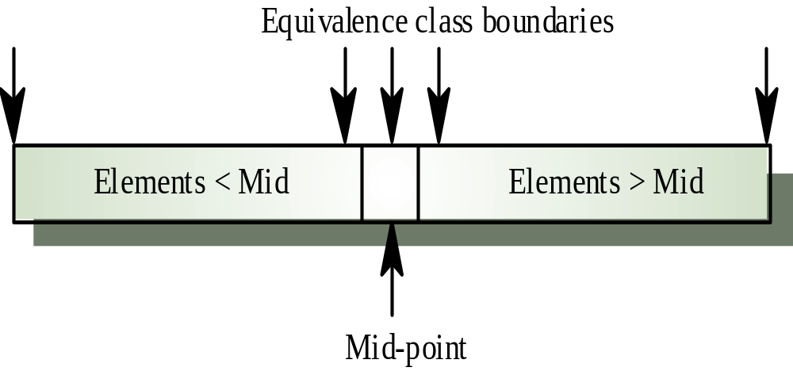

Binary search - equivalent partitions

- Pre-conditions satisfied, key element in array

- Pre-conditions satisfied, key element not in array

- Pre-conditions unsatisfied, key element in array

- Pre-conditions unsatisfied, key element not in array

- Input array has a single value

- Input array has an even number of values

- Input array has an odd number of values

NOTE: the last two tests were added based on the knowledge of the code
Binary search - test cases

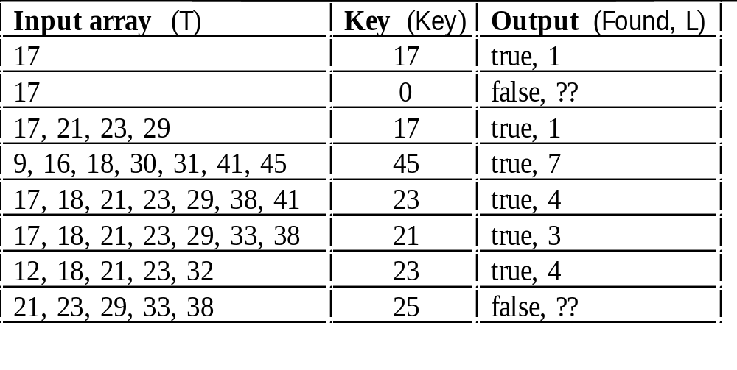
Program flow graph

- Describes the program control flow

- Used as a basis for computing the cyclomatic complexity

- Complexity =
Number of edges - Number of nodes +2

Control Flow Patterns

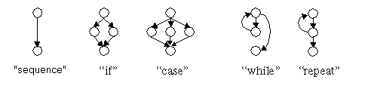

Binary Search Flow Graph

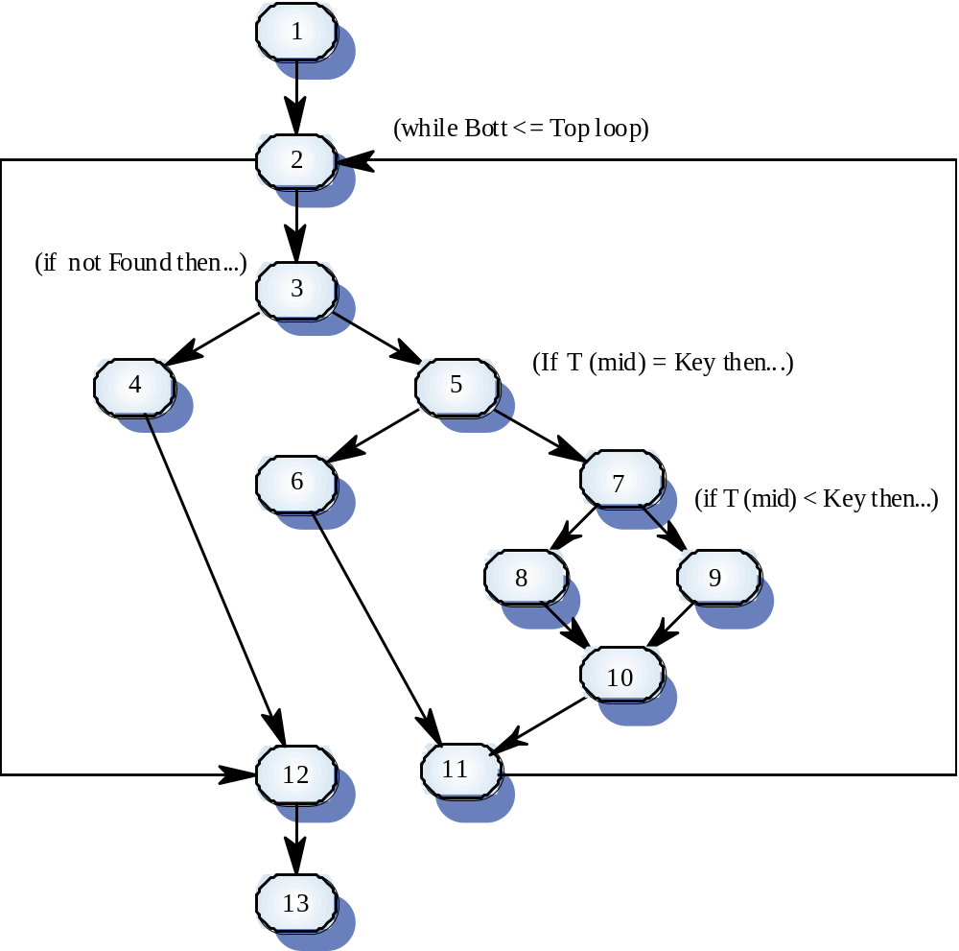

Independent paths

- , 2, 3, 4, 12, 13 1
- 1, 2,3, 5, 6, 11, 2, 12, 13
- 1, 2, 3, 5, 7, 8, 10, 11, 2, 12, 13
- 1, 2, 3, 5, 7, 9, 10, 11, 2, 12, 13

- Test cases should be derived so that all of these paths are executed

- A dynamic program analyzer may be used to check that paths have been executed

Cyclomatic complexity

- Independent program path:
traverses at least one new edge in the
flow graph (i.e. explores one or more
new conditions)

- The number of independent paths is the number of tests needed to test all control statements
It is <= the cyclomatic complexity

- Cyclomatic complexity equals
number_of_conditions + 1

- Useful if used with care. Does not imply adequacy

- Does not take into account data-driven
programs

Control and data-driven programs

Two solutions for the same problem:

Control driven
case A is
when “One” => i := 1 ;
when “Two” => i := 2 ;
when “Three” => i := 3 ;
when “Four” => i := 4 ;
when “Five” => i := 5 ;
end case ;

Cyclomatic complexity: 6

Data driven
Strings: array (1..4) of STRING :=
(“One”, “Two”, “Three”, “Four”, “Five”);
i := 1 ;
loop
exit when Strings (i) = A ;
i := i + 1 ;

end loop

Cyclomatic complexity: 2

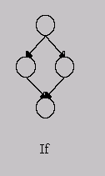Analysis of logical conditions

Check each branch at least once

- For complex expressions: check for all possible values of sub-expressions
E.g. for if A && B then … else …
need 4 checks, not 2

- Analyze all assumptions on possible causes of errors

- For each error assumption, provide a test on which the given code behaves differently from the code that is assumed to be correct.

- For each test, compare its result with the expected according to module’s spec

Possible Reasons for Errors

- Incorrect boundary:
x >= 9 instead of x >= 8
x > 10 instead of x >=10

- Misunderstanding of negation:
> viewed as negation of <

- Incorrect choice of operation:
|| instead of &&

- Misunderstanding of operation order:
not A && B instead of not (A &&B)

- “Misspelling” in operation:
& instead of &&

- Wrong assumption about order of computation supported by compiler:
if (x == 0 || (y%x > 5)) …

Analysis of Loops (simple case)

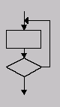
- Skip the loop
- Execute the loop only once
- Execute the loop more than once
- Execute the loop N-1, N, N+1 times

Possible reasons for errors

- loops are often thought as executed >1 times

- wrong initialization of loop variable;
typical case: 1 instead of 0

- wrong treatment of boundary cases:
while (x < 100) instead of while (x<=100)

- wrong update of loop variable:
i++ instead of i=i+2

- no update of loop variable (infinite loop)
Analysis of Loops (nested loops)

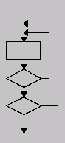
- Start with innermost loop, while other loops initialized with their initial values

- Perform the simple case checks for the innermost loop

- Check the next level loop (the one that contains the already tested loop)

- Repeat until all loops are tested

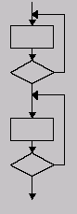Sequential Loops

- For each loop perform the relevant check
(simple case, or nested loops check)

Coverage Criteria – a summary

Typical coverage criteria:
- execute all paths:
- impossible in programs with loops
- not realistic in complicated programs
- execute each statement at least once
- execute each branch at least once
- the branch criteria is stronger: in some cases, can execute all statements without executing all branches

More advanced control flow coverage criteria:
- loop coverage:
# loop is skipped
# loop is executed exactly once
# loop is executed more than once
- multi-condition coverage
e.g. if (A && B) then … else …
need to check all possible combinations for A and B

Data flow coverage criteria:

- a data flow path: leads from setting of a data to its reference

- for every data X, cover all paths from every assignment of a value to X to all uses of this value (impossible or non-realistic)

- for every assignment of a value to X and every use of this value, cover at least one path connecting them
# more realistic
# branch coverage is not enough to achieve this

- for every assignment of a value to X, cover at least one path leading to some use of this value (might be too weak)

Ways to achieve a good coverage

- combine black & white box testing

- start with functional set of tests (black box)

- white box extensions of the obtained set:
- cover remaining statements or branches
- provide loop coverage and logical (multi-condition coverage)
- add tests to provide the data flow coverage

Feasible for relatively small units
Tools help to do the job

